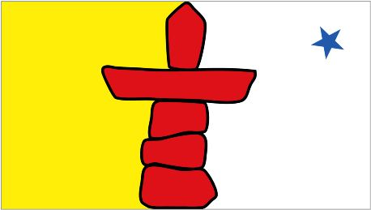

INUKTITUT NORTH GRENVILLE

Student Registration Form

First Name: Last Name:
Address:
City: Province: Postal Code:
Home Telephone: Cell Phone:
Email Address:

InuktitutNG language, culture and traditions classes will be held at:
St. Michael’s High School, 2755 County Road 43,
Kemptville, ON

Cost is $195, plus materials (approx. $30)

Every Tuesday evening, starting October 2, 2018 for 8 weeks
Classes are 7:00pm until 9:00pm - please arrive 10 minutes early

EMAIL COMPLETED FORM TO:
anne@alkeventmanagement.ca

You will receive an invoice with a link, to pay for the course online

www.alkeventmanagement.ca 613-853-8308

