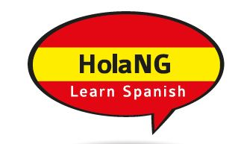
HOLA - North Grenville SPANISH CLASSES

Student Registration Form

First Name: Last Name:
Address:
City: Province: Postal Code:
Home Telephone: Cell Phone:
Email Address:

Choose location: ☐ Kemptville (beginner or intermediate) ☐ Brockville (beginner only)

Choose level:

☐ Beginner

☐ Intermediate

Kemptville HolaNG Classes (beginner and intermediate) will be held at
St Michaels High School, 2755 County Road 43,
Kemptville, ON

Brockville HolaNG Classes (beginner only) will be held at
Bridlewood Manor (Revera), 1026 Bridlewood Drive, Brockville, ON

Cost is $195 plus HST, plus books (approx. $95)

Beginners – starting Thursdays October 3, 2019 – 8 weeks
Intermediate – starting Wednesdays October 2, 2019 – 8 weeks

Classes are 6:30pm until 8:30pm - please arrive 10 minutes early

EMAIL COMPLETED FORM TO:
anne@alkeventmanagement.ca

You will receive an invoice with a link, to pay for the course online

www.alkeventmanagement.ca 613-853-8308

