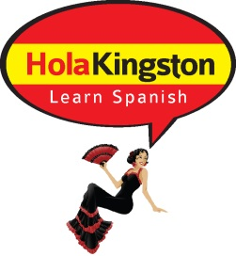

HOLA-KINGSTON SPANISH CLASSES

Student Registration Form

First Name: Click here to enter text. Last Name: Click here to enter text.
Address: Click here to enter text.
City: Click here to enter text. Province: Click here to enter text. Postal Code: Click here to enter text.
Home Telephone: Click here to enter text. Cell Phone: Click here to enter text.
Email Address: Click here to enter text.
Emergency Contact Name: Click here to enter text.
Emergency Contact Number: Click here to enter text.

Spanish Language History
Would you consider yourself:
☐ Beginner (no Spanish training at all)
☐ Basic (Elementary school and/or life experience)

HolaKingston Classes will be held at
191 Portsmouth Avenue, Kingston, ON
(beside the Public Health Building)
Cost is $195 plus HST

Tuesday nights, September 22 to November 10, 2015 – 8 weeks

Classes are 6:30pm until 8:30pm - please arrive 10 minutes early

EMAIL COMPLETED FORM TO:
anne@alkeventmanagement.ca

You will receive an invoice with a link, to pay for the course online

www.alkeventmanagement.ca 1-866-246-6888 or 613-853-8308

