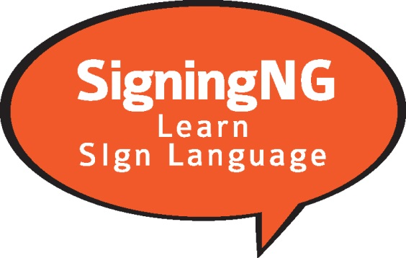

American Sign Language

Student Registration Form

First Name: Last Name:
Address:
City: Province: Postal Code:
Home Telephone: Cell Phone:
Email Address:

Choose the level of Sign Language you are registering for

Level 1: Level 2:

$295 plus HST for Classes
Student Materials - $95 plus HST (level 1 & level 2 book)

Level 1 ASL - Tuesdays starting October 1, 2019 from 6:00-8:30pm
Level 2 ASL – Thursdays starting October 3, 2019 from 6:00pm-8:30pm

Classes will run for 8 to 10 weeks (depending on class size)
Classes will be held at
St Michaels High School,
2755 County Rd 43
Kemptville, ON

EMAIL COMPLETED FORM TO:
anne@alkeventmanagement.ca

You will receive an invoice with a link, to pay for the course online

www.alkeventmanagement.ca 613-853-8308

