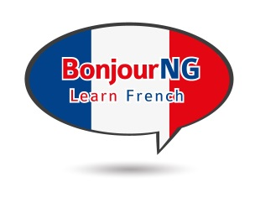
BonjourNG French Classes

Student Registration Form

First Name: Last Name:
Address:
City: Province: Postal Code:
Home Telephone: Cell Phone:
Email Address:

Location: ☐ Kemptville ☐ Brockville (if registering for Winchester classes, see link on website)

☐ Beginner (very little French training, basic Ontario elementary curriculum only) – Thursdays
☐ Intermediate (high school, university, family history) – Wednesdays
☐ Advanced (conversational, but need a refresher and to converse with others) - Tuesdays

Kemptville Courses will be held at St Michael’s High School,
2755 County Road 43, Kemptville, ON

Brockville Courses held at The Children’s Centre Ange Gabriel Daycare, 1515 Kensington Parkway, Brockville, ON

Cost is $195 for lessons, $95 for books plus HST

Beginner – Thursday October 4th (Brockville), 11th (Kemptville), 2018
Intermediate – Wednesday October 3 (both Brockville & Kemptville)
Advanced – Tuesday October 2 (both Brockville & Kemptville)

Classes are 6:30pm until 8:30pm, and run for 8 weeks
Please arrive 10 minutes early
(minimum numbers required to proceed with classes)

EMAIL COMPLETED FORM TO:
anne@alkeventmanagement.ca

You will receive an invoice with a link, to pay for the course online

www.alkeventmanagement.ca 613-853-8308

