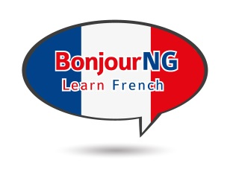
BonjourNG French Classes

Student Registration Form

First Name: Last Name:
Address:
City: Province: Postal Code:
Home Telephone: Cell Phone:
Email Address:

Location: ☐ Kemptville ☐ Brockville

☐ Beginner (very little French training, basic Ontario elementary curriculum only)
☐ Intermediate (high school, university, family history)
☐ Advanced (conversational, but need a refresher and to converse with others)

Kemptville Courses will be held at St Michael’s High School,
2755 County Road 43, Kemptville, ON

Brockville Courses held at The Children’s Centre Ange Gabriel Daycare, 1515 Kensington Parkway, Room 162, Brockville, ON

Cost is $195 for lessons, $95 for books, plus HST

Spring 2020 Classes - run for 8 weeks, starting on the following dates:
Beginner – Monday Apr 27 (Brockville), Thursday Apr 30 (Kemptville)
Intermediate – Tuesday Apr 28 (Kemptville), Wednesday Apr 29 (Brockville)

Classes are 6:30pm until 8:30pm, and run for 8 weeks
Please arrive 10 minutes early
(minimum number of 8 students required to proceed with classes)

EMAIL COMPLETED FORM TO:
anne@alkeventmanagement.ca

You will receive an invoice with a link, to pay for the course online

www.alkeventmanagement.ca 613-853-8308

