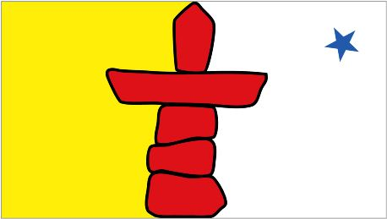

Canadian Inuit Culture & Language Course - Vanier

Student Registration Form

First Name: Last Name:
Address:
City: Province: Postal Code:
Home Telephone: Cell Phone:
Email Address:

Canadian Inuit Culture & Language classes will be held at:
St. Margaret’s Anglican Church, 206 Montreal Rd, Vanier

Cost is $295, plus materials (approx. $30)

Classes are Friday afternoons, starting October 5, 2018 for 5 weeks
Three hours from 1:00pm to 4:00pm - please arrive 10 minutes early

EMAIL COMPLETED FORM TO:
anne@alkeventmanagement.ca

You will receive an invoice with a link, to pay for the course online

www.alkeventmanagement.ca 613-853-8308

